**Practical 7:**

**Aim: Create an ID3 based classification model for the given dataset.**

**Solution:**

**Using weather.nominal.arff**

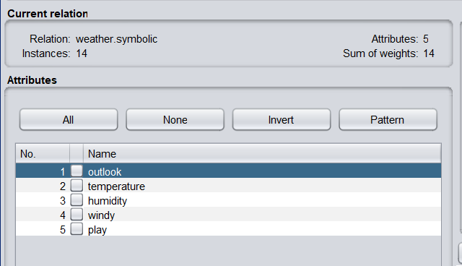

**Selecting j48 algorithm from classifier**

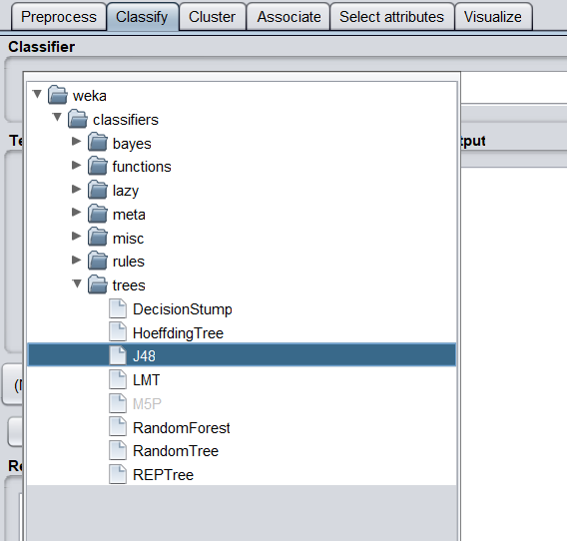

**Output:**

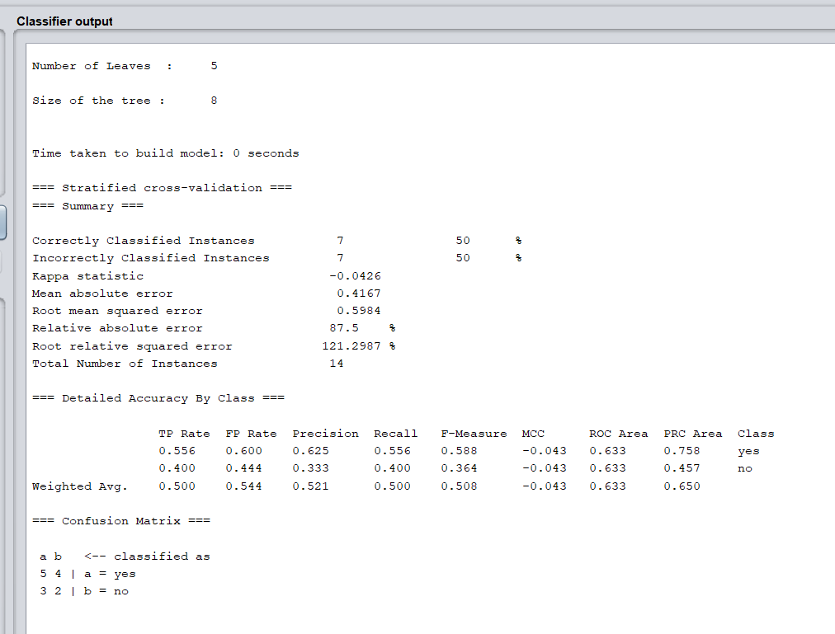

**Visualizing tree**

